Date:__________________
Operator:______________
Product: Walmart 8# Pouch Line:__________________

Check each block below as the line is prepared for the run. Lead Operator also Supervisor and/or Quality are the only authorized signature. By signing; you are taking full responsibility for the product. Form should be turned into the Production Supervisor at the end of the shift or end of the product run.

Line Clearance:
- Pouches or Cartons Removed ⁯ Corrugated Materials Removed ⁯ Labels Removed
- Pack and Stack Area Cleared ⁯ All Paperwork Turned In
Pouch Specifications:
- Pouch is blue, white and red
- CPU#: 3 49580 39508 4 Above Barcode PLD-A331C SE000191
- Dimensions of pouch: 13.75” H x 10.0 "W x 4.0” Bottom Gusset
Case Specification:
- Case is brown corrugated with blue print
- Case has WALMART 8lb EPSOM SALT; Item#554179192 ; UPC#349580395084 ; Barcode10349580395081
- Case dimensions: 6.25"H x 13.375"W x 12.0”D
Packing Specification:
- 4 ct. pouches / case, packed horizontally into case; 216 pouches per full pallet.
- Quantity of Pallets: __________________________________________________________
- Date Code on Pouch: ________________________________________YYJJJ EXP MMYY
- Date Code on Box: _________________________________________ YYJJJ EXP MMYY
Pallet Configuration:
- 9 cases per layer, 6 column stacked high = 54 cases per pallet
Carton and Pouch Waste:
- Starting Inventory Balance:___________________
- Total Used in Production:_____________________
- Pallet Markers:_____________________________
- Ending Inventory Balance:____________________
- Number of cases not making up a full pallet:______
- Number of containers not making a full case:______

Operator Signature: _____________________________________________ Date: ______________

Supervisor Signature: ____________________________________________ Date: ______________

Quality Signature: _______________________________________________ Date: ______________

Scale Information Breakdown:
Reject:_____________________
Over:______________________
Average:___________________
Std. Dev.:__________________
Max:______________________
Min:______________________

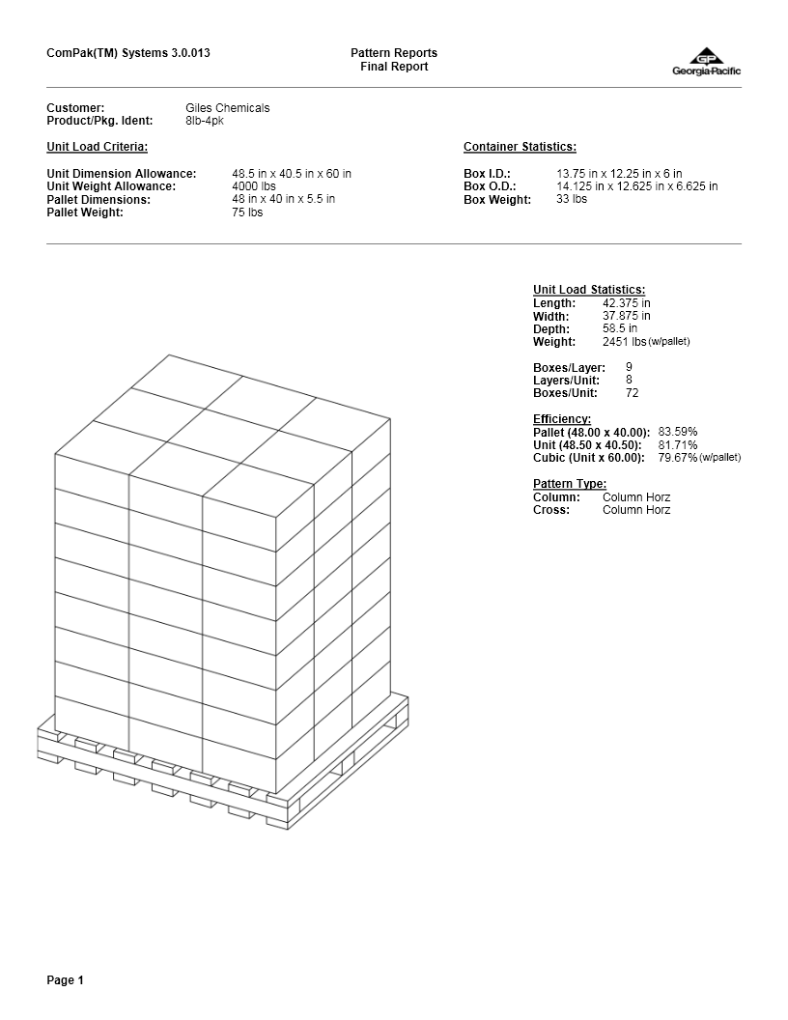
7 M.P. 11/5/15
63

